Licensed Software Installation
Request Management in ServiceNow
ServiceNow Custom Application
Project | Details
Project | Licensed Software Installation Request
Platform | ServiceNow
Interface | Service Portal / Service Catalog
Workflow | Catalog → REQ/RITM → License Validation → Approval → Task → Fulfillment → Notification

TABLE OF CONTENTS
S. No. | Chapter / Section | Page No.
1 | Project Overview | 3
2 | Problem Statement and Objectives | 3
3 | Application and Data Architecture | 3-4
4 | Requirement Analysis and Planning | 4
5 | Catalog Item and Variable Configuration | 4-5
6 | Service Portal Interface and Usability | 5
7 | Flow Designer Automation | 6
8 | End-to-End Functional Flow | 7
9 | Testing and Validation | 7
10 | Deployment, Documentation and Presentation | 7-9
10 | Conclusion and Future Enhancements | 10

1. Project Overview
The Licensed Software Installation Request project provides a structured and automated way for employees to request installation of licensed software through the ServiceNow Service Catalog. The solution manages the request from submission through license validation, approval, fulfillment, notification, and closure.
Employees can submit licensed software requests through the Service Catalog.
Required software, employee, device, business, urgency, and license information is captured.
ServiceNow creates Request and Requested Item records.
The workflow retrieves catalog variables and checks license availability.
Approved requests generate a Catalog Task for the Software Support Team.
Notifications and SLAs provide process visibility and time-based monitoring.
Dashboard and Update Set configuration support reporting and deployment.
2. Problem Statement and Objectives
Software installation requests can become difficult to control when they are submitted through unstructured channels. This project provides a centralized ServiceNow process for collecting complete request information, validating licensing, obtaining approval, creating fulfillment tasks, and communicating progress.
Objectives
Create a centralized Licensed Software Installation Request Catalog Item.
Capture complete request information using structured catalog variables.
Automate license validation and approval.
Create software installation tasks automatically after approval.
Route fulfillment work to the Software Support Team.
- Monitor processing time using SLAs.
- Send notifications at important stages.
- Provide dashboard visibility and controlled deployment through Update Sets.

3. Application and Data Architecture
The solution is developed on ServiceNow using Service Catalog, Requested Item records, workflow automation, approvals, Catalog Tasks, notifications, SLAs, dashboard reporting, and security controls.
Application flow:
Catalog Item → REQ/RITM → Catalog Variables → License Validation → Approval → Software Asset Approval → Catalog Task → Fulfillment → Notification → Closure

Component | Purpose
Service Catalog | Employee-facing request entry point.
Catalog Variables | Capture software and installation requirements.
UI Policies / Client Scripts | Control form behavior and validation.
Workflow / Flow Designer | Automate processing and decisions.
License Validation | Check requested software licensing.
Approval | Control whether request may proceed.
Catalog Task | Provide fulfillment work item.
Assignment Group | Route task to Software Support Team.
Notifications | Communicate key events.
Dashboard | Provide operational visibility.
Update Set | Package configuration for deployment.

4. Requirement Analysis and Planning
The project requirements were identified to automate the complete licensed software installation process.

Functional Requirements
- Users submit requests through the Service Catalog.
- Required details are captured using catalog variables.
- REQ and RITM records are created.
- License availability is validated.
- Approval is obtained before fulfillment.
- Approved requests create a Catalog Task.
- Tasks are assigned to Software Support Team.
- Users receive status and completion notifications.
- SLAs support priority-based processing.
- Access is controlled using roles and ACLs.
Planning covered catalog configuration, form customization, UI logic, workflow automation, approval and license validation, task and notification configuration, testing, security, deployment, and documentation.

5. Catalog Item and Variable Configuration
A dedicated Licensed Software Installation Request Catalog Item was configured to allow employees to submit software installation requests.
Variable | Purpose
Which software do you want? | Requested software.
Which software version you want? | Required version.
Business Justification | Business need.
By which date you need it? | Required installation date.
Enter employee name | Employee identification.
Where do you want to install your software/device? | Target device.
Enter your manager name | Approval routing.
Enter your department name | Department.
Urgency | Priority and SLA path.
Select License Type | Licensing category.
These variables ensure complete and accurate information is available for downstream validation, approval, and fulfillment.
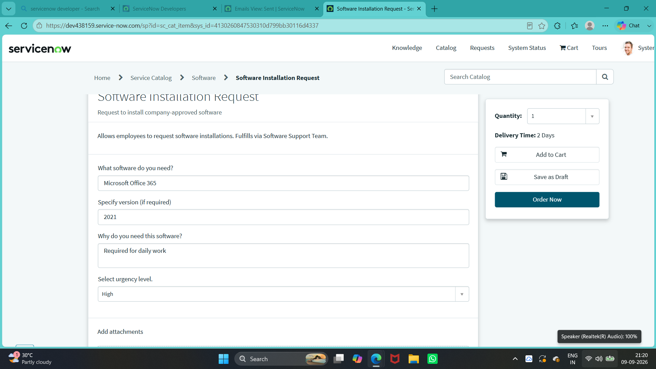
Fig 5.1 – Licensed Software Installation Request – Configured Catalog Variables / Request Details

6. Service Portal Interface and Usability
The Service Portal provides a simple interface for employees to submit licensed software requests. The form groups software, requester, installation, business, urgency, and licensing information so users can provide complete details before submission.
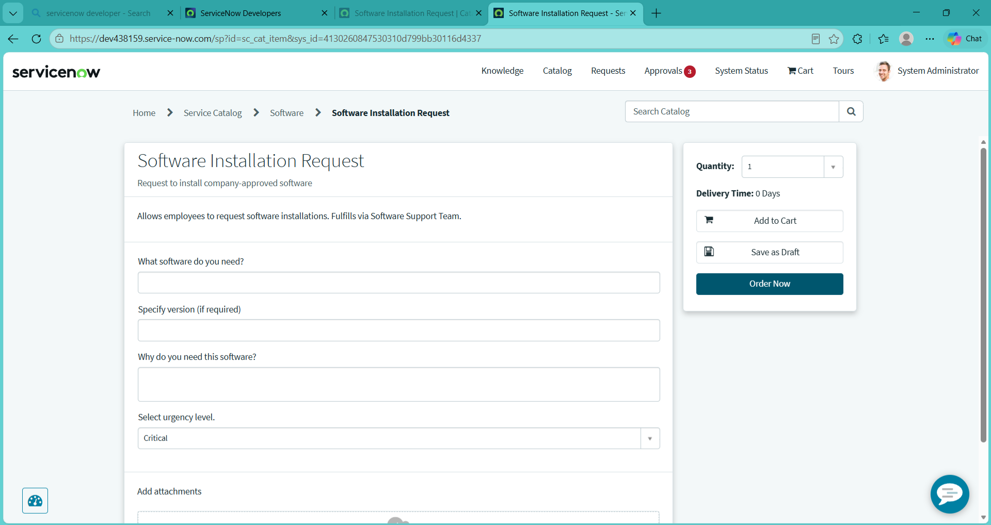
Fig 6.1 – Licensed Software Installation Request – User-Friendly Catalog Form

7. Workflow Automation and Approval
The SIRA_Software_Installation_Workflow automates catalog-variable retrieval, urgency processing, license lookup, approval, software asset approval, Catalog Task creation, record updates, and notifications.
Workflow:
Request Submission → Get Catalog Variables → Priority Processing → License Lookup → Approval → Asset Approval → Catalog Task → Update Record → Notification
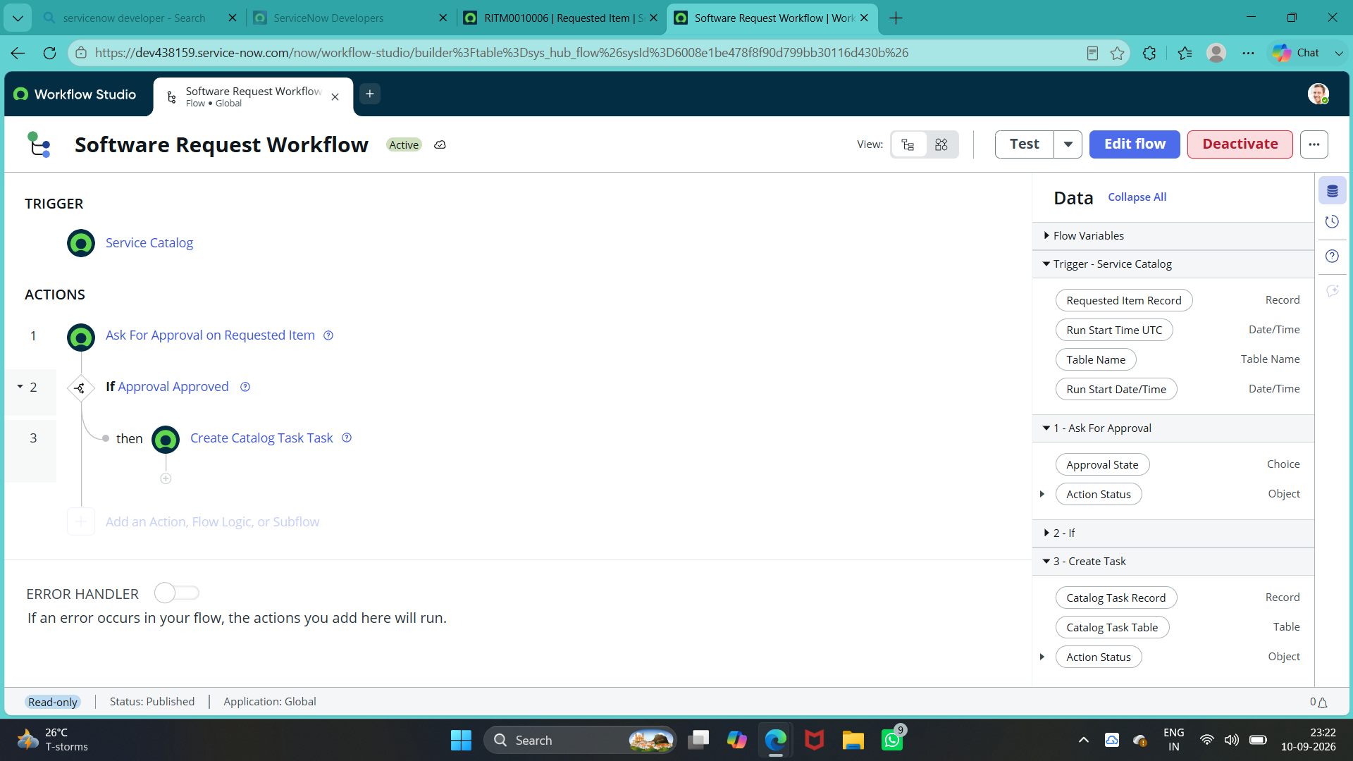
Fig 7.1 – Licensed Software Installation Request – Software Request Workflow

Approval
The request is routed for approval before fulfillment. Approved requests proceed to asset validation and task creation; rejected requests follow the configured rejection and notification path.
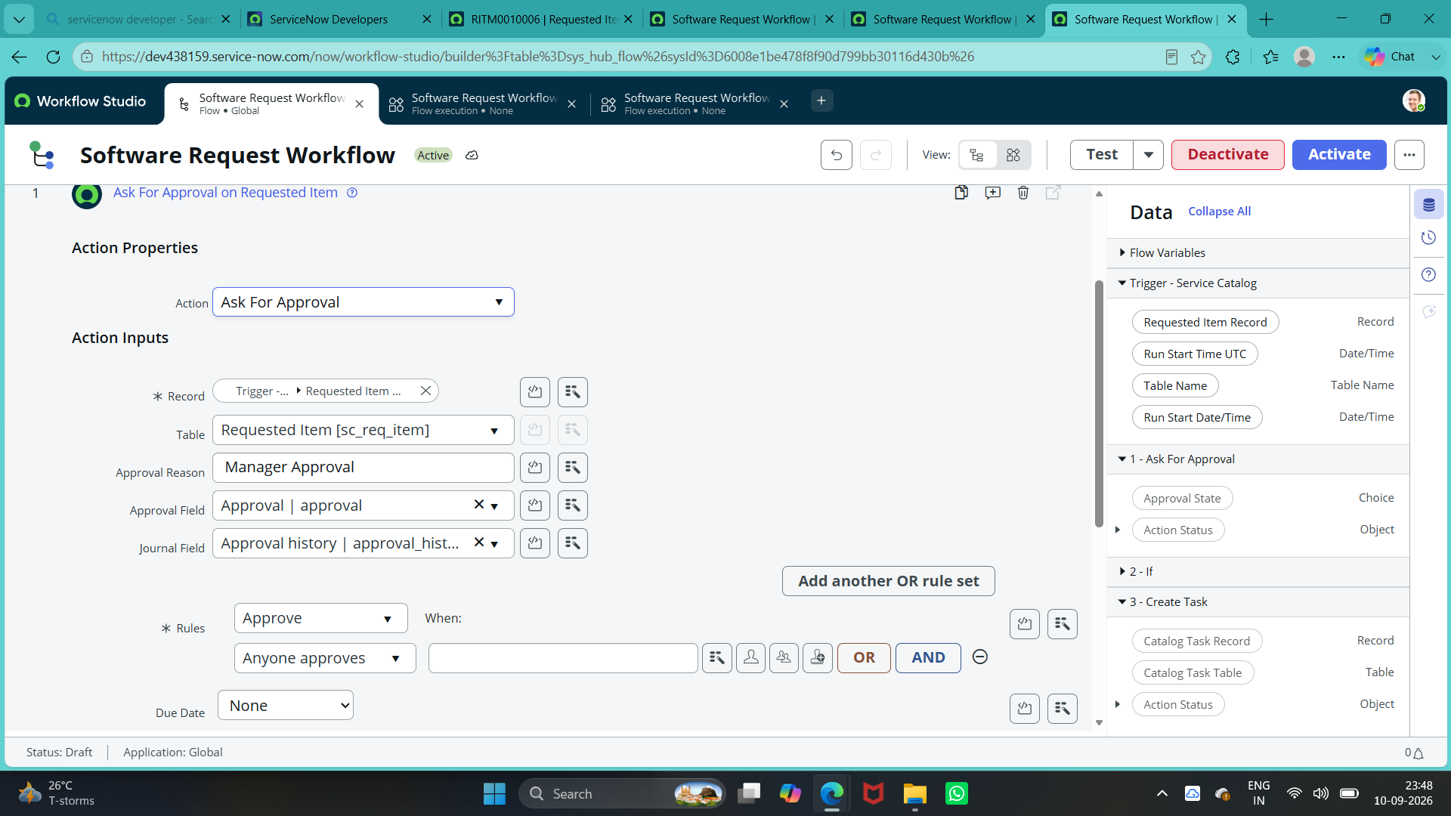
Fig 7.2 – Licensed Software Installation Request – Workflow(Approvals)

8. End-to-End Functional Flow
- Employee opens the Licensed Software Installation Request.
- Employee enters catalog variables and submits the request.
- ServiceNow creates REQ and RITM records.
- Workflow retrieves catalog variables.
- Urgency and SLA path are evaluated.
- License information is checked.
- Request is routed for approval.
- Approved request proceeds through software asset approval.
- Catalog Task is created and assigned to Software Support Team.
- Support team installs the software.
- Task and request are updated to completion.
- Requester receives notifications.

9. Testing and Security Validation
Testing verifies the complete request process from catalog submission through fulfillment and closure.
Test Area | Expected Result
Catalog submission | Complete request submits successfully.
Mandatory fields | Incomplete requests are prevented.
REQ/RITM creation | Records are created correctly.
License validation | License information is checked.
Approval | Correct approval stage is reached.
Task creation | Approved request creates Catalog Task.
Assignment | Task reaches Software Support Team.
Notifications | Configured notifications are generated.
Completion | Fulfillment is recorded.

10. Deployment, Documentation and Final Presentation
The completed configuration is captured in the SIRA_Workflow_Automation Update Set for controlled tracking and movement between ServiceNow instances.
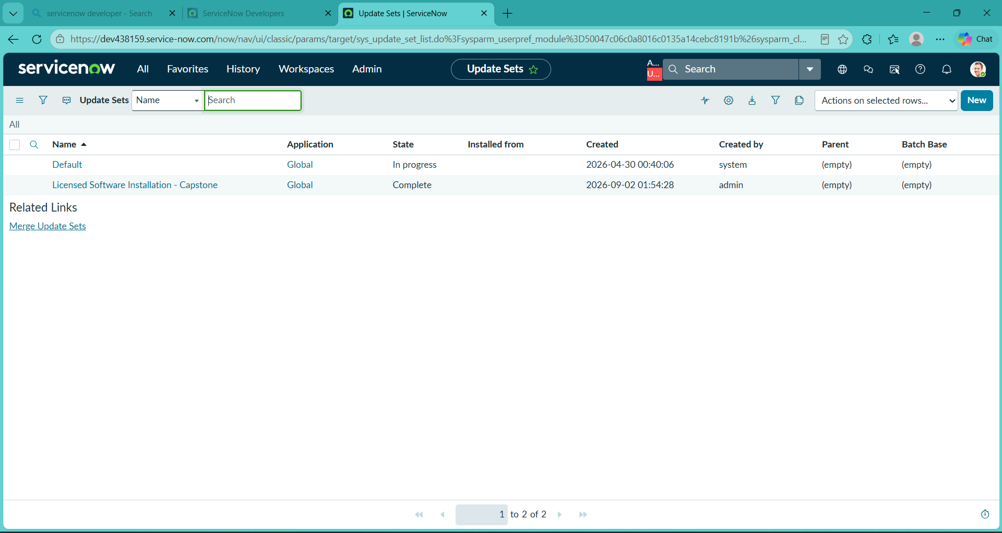
Fig 10..1 – Licensed Software Installation Request – Update Set completed
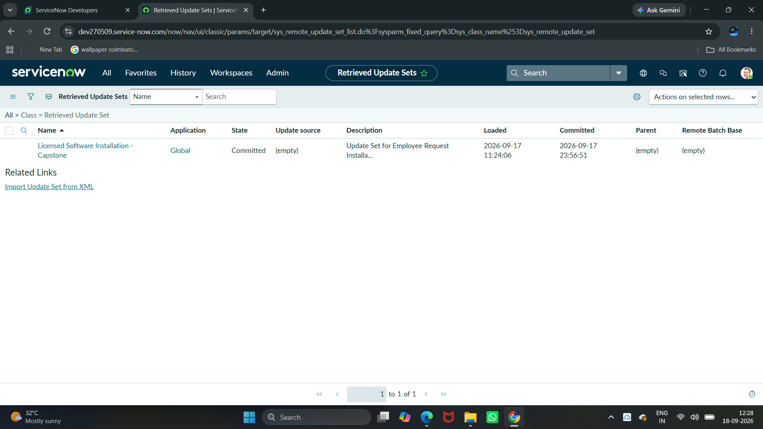
Fig 10.2 – Retrieved / Committed Update Set Evidence
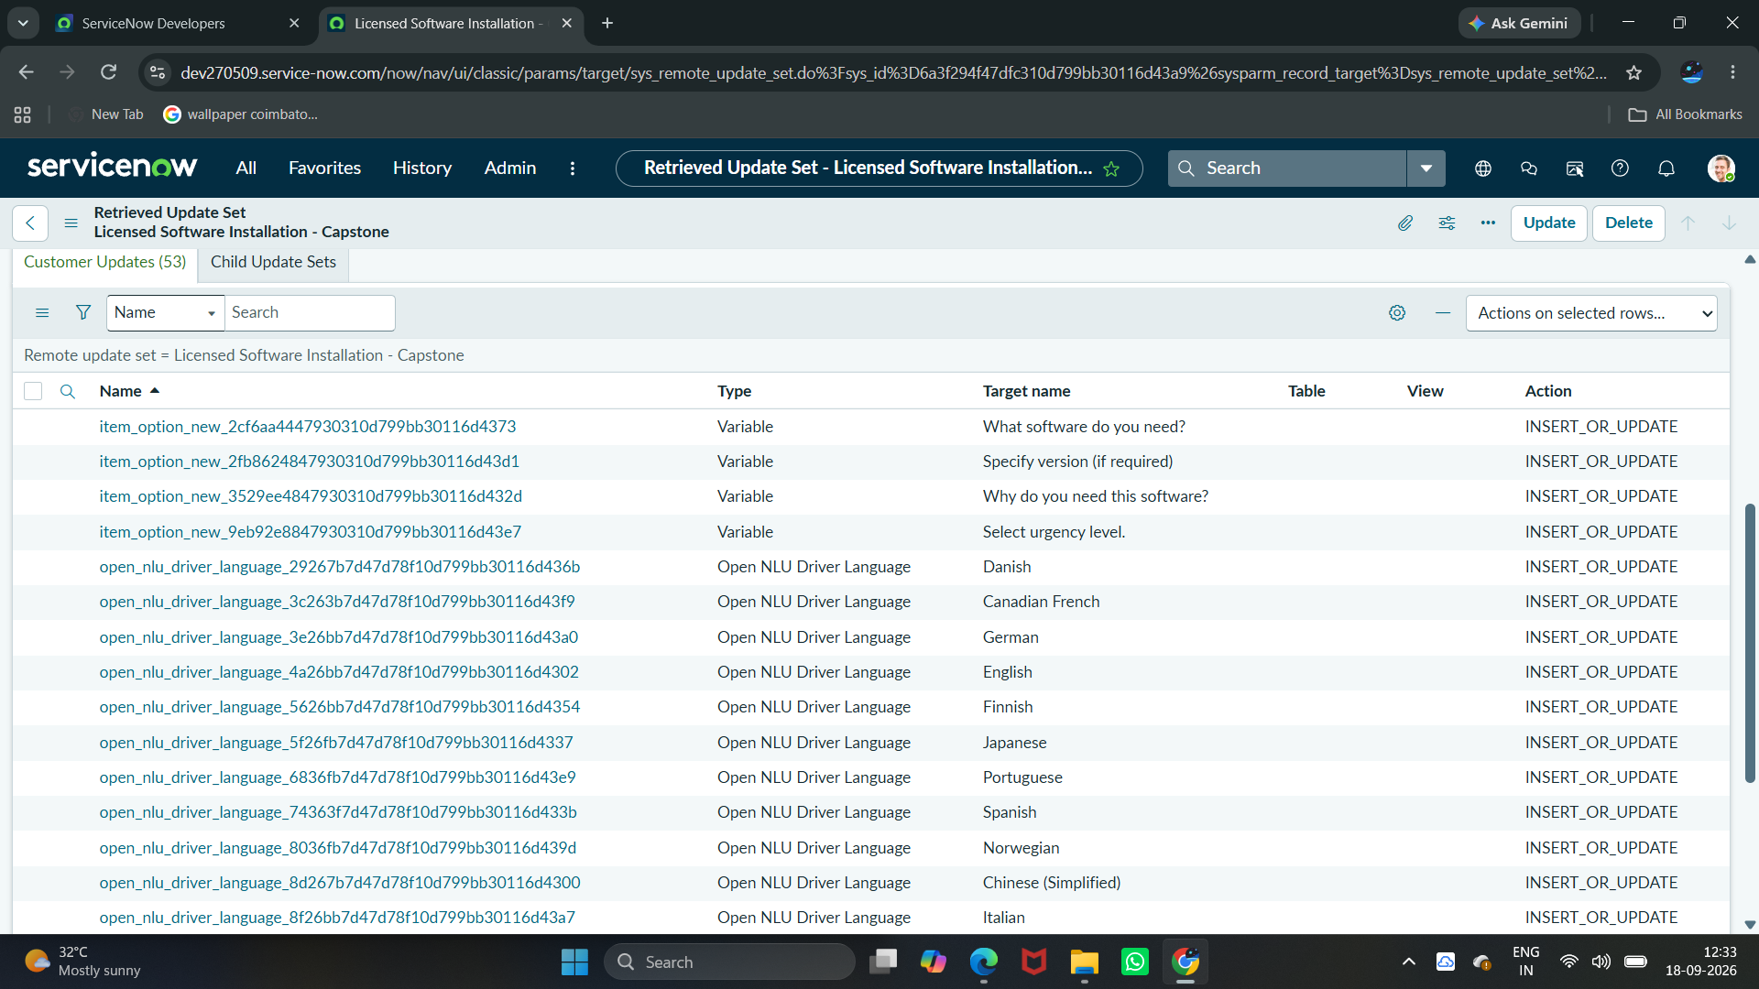
Fig 10.3 – Licensed Software Installation Request-Customer Updates

Documentation
The documentation records the project requirement, architecture, catalog configuration, UI logic, workflow, approval, license validation, task fulfillment, notifications, SLA, testing, security, deployment, and final outcome.

Final Presentation
The final presentation demonstrates the complete lifecycle from employee request submission to approval, software installation task, fulfillment, notification, dashboard reporting, and deployment evidence.

11. Conclusion and Future Enhancements
The Licensed Software Installation Request solution successfully centralizes and automates the process of requesting licensed software through the ServiceNow Service Catalog. The implementation connects structured request intake with license validation, approval, automated task creation, fulfillment, SLA monitoring, notifications, security, reporting, and deployment.
The solution reduces manual effort, improves visibility, supports controlled use of licensed software, and provides a traceable request lifecycle for employees and IT support teams.

Future Enhancements
- Add more software products and versions.
- Introduce additional approval levels for restricted or high-cost licenses.
- Expand license inventory and availability automation.
- Add more dashboard reports and analytics.
- Improve automated fulfillment and software deployment integration.
- Enhance role-based access and validation.

